CAMPFIRE SAFETY

- BUILD FIRE IN AN OPEN AREA OF DIRT, ROCK, OR SAND AT LEAST SIX FEET AWAY FROM TREES, BUSHES, OR FALLEN LOGS. NEVER BUILD A FIRE AGAINST A FALLEN TREE, A LARGE LOG, OR A STUMP WHO’S ROOTS GO INTO THE GROUND. THE FIRE MAY RAPIDLY BECOME UNCONTROLLABLE OR TRAVEL ALONG UNDERGROUND ROOTS FOR SOME DISTANCE.

- CLEAR THE GROUND WITHIN A RADIUS OF SIX FEET BY SCRAPING AWAY DRY LEAVES, DRY GRASS, TWIGS, AND PINE NEEDLES DOWN TO ROCKS AND SOIL. HOLLOW OUT A SECTION OF GROUND IN THE CENTER IN WHICH TO BUILD THE FIRE. ROCKS, WHICH CONDUCT HEAT, MAY BE USED TO LINE THE HOLE, BUT AVOID ROCKS CONTAINING LIMESTONE, SHALE, OR MOISTURE, WHICH WILL EXPLODE WHEN THEY COME IN CONTACT WITH HEAT.

- GATHER TINDER, KINDLILNG, AND FUEL BEFORE STARTING THE FIRE.

TINDER SHOULD BE IN PIECES LONGER, BUT NO THICKER
THAN A MATCH. FINE TWIGS, BUNDLES FROM TOPS OF
BUSHES AND WEEDS, PIECES OF PINE, THIN PIECES OF
BARK, AND DRIED LEAVES AND GRASS MAKE GOOD
TINDER.

KINDLING IS DRY STICKS AND TWIGS FROM JUST LARGER
THAN TINDER TO THUMB THICKNESS, IN SIX TO TWELVE
INCH LENGTHS. LARGER PIECES OF WOOD MAY BE SPLIT
INTO KINDLING. KINDLING SHOULD SNAP WHEN BROKEN.
DEAD BRANCHES FROM LOWER LIMBS OF TREES ARE
BEST BECAUSE THEY ARE PROBABLY DRIER THAN
STICKS FOUND ON THE GROUND. STICKS THAT BEND
WITHOUT SNAPPING ARE PROBABLY GREEN AND WILL BE
HARD TO BURN.

FUEL IS FIRM PIECES OF WOOD. FUEL CAN EVEN BE FAIR
SIZED LOGS, DEPENDING ON USE. AN ADEQUATE
WOODPILE SHOULD BE NEAR THE FIRE FOR CONVENIENCE,
BUT FAR ENOUGH AWAY FOR SAFETY. A GOOD CAMPER
NEVER HAS TO SEARCH FOR WOOD AFTER THE FIRE IS LIT.

- BUILD FIRES NO LARGER THAN NEEDED FOR THE SPECIFIC PURPOSE. COOKING FIRES SHOULD BE JUST LARGE ENOUGH TO HEAT THE KETTLE USED. LARGE FIRES WASTE FUEL, ARE HARD TO CONTROL, AND ARE DIFFICULT TO WORK OVER.

- KEEP FIRES UNDER CONTROL. FIREFIGHTING TOOLS, SUCH AS WATER, SAND, SHOVELS, AND BROOOMS SHOULD BE READILY AVAILABLE.

- NEVER LEAVE A FIRE UNATTENDED, AND NEVER GO TO SLEEP BEFORE THE FIRE IS COMPLETELY OUT. STAY CLOSE TO IT, AND WATCH IT CAREFULLY.

- EXTINGUISH THE FIRE COMPLETELY BEFORE LEAVING THE AREA.

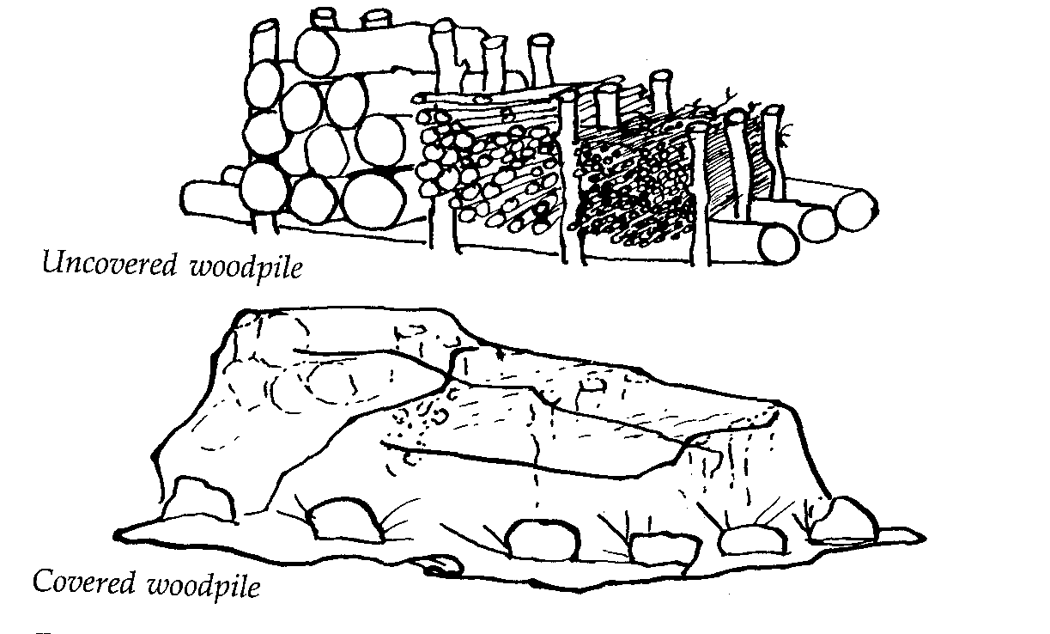

METHODS OF STARTING A FIRE

STEEL AND FLINT—THINLY SEPARATED STEEL WOOL AND A FEW PIECES OF TINDER. PLACE FLINT BAR NEXT TO THE STELL WOOL, AND STRIKE THE FLINT WITH POKETKNIFE TO IGNITE THE WOOL. BLOW ON THE WOOL UNTIL THE SPARKS ARE NUSED INTO A FLAME; THEN ADD SOME MORE TINDER.

FLASHLIGHT BATTERIES AND STEEL WOOL—TEAR STEEL WOOL INTO A STRIP ONE-HALF INC WIDE AND ABOUT EIGHT OR NINE INCHES LONG. PLACE ONE BATTERY ON THE TOP OF THE OTHER BATTERY IN AN UPRIGHT POSITION, HOLDING ONE END OF THE STEEL WOOL AGAINST THE BOTTOM OF THE LOWER BATTERY. RUB THE OTHER END ACROSS THE TOP BATTERY. SPARKS WILL BE THROWN OFF, SO WORK NEAR THE TINDER AND BLOW TO START A FIRE.

MATCHES—WHITTLE A STICK, LEAVING SHAVINGS ON THE END; THIS IS CALLED A FUZZ STICK. PLACE A FORKED STICK IN THE GROUND TO KEEP THE TINDER ELEVATED; ADD TINDER TO FORM A TEPEE, LEAVING A SPACE AT THE BOTTOM IN WHICH TO INSERT THE MATCH AND FUZZ STICK.

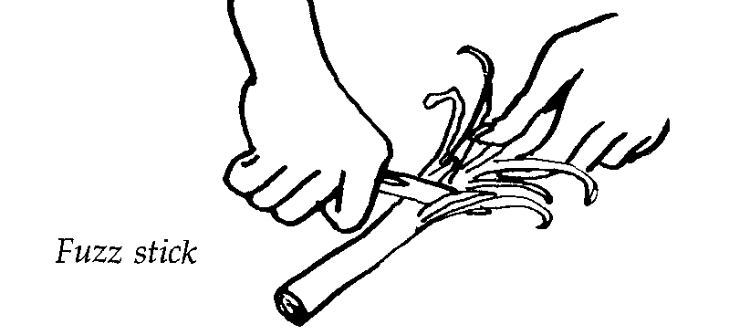

TYPES OF FIRES AND THEIR USES

TEPEE FIRE—BUILT AS A BASIS FOR ALL OTHER TYPES.
IT IS OFTEN USED WITH THE LOG CABIN
ORCRISSCROSS FIRE IN COUNCIL FIRES. IT
IS ALSO USED IN REFLECTOR OVEN BAKING
BECAUSE IT MAKES A HIGHER FLAME.

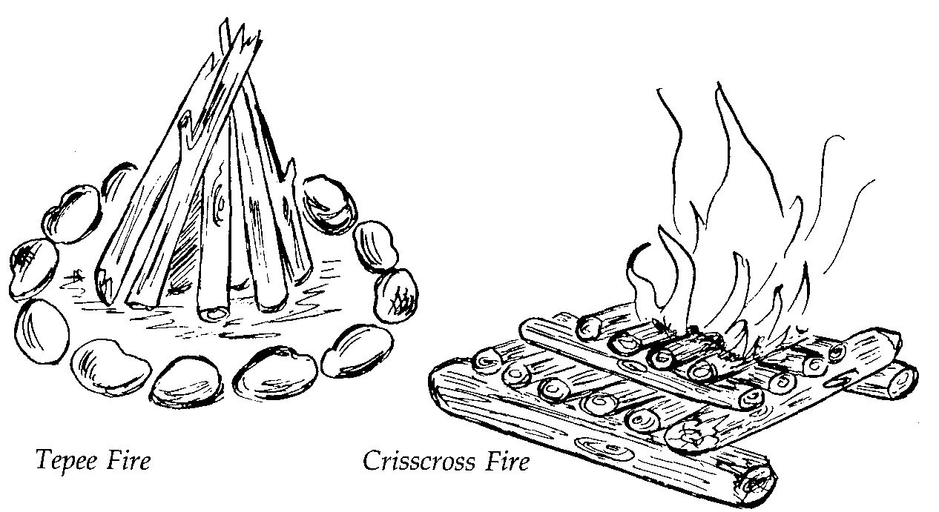

CRISSCROSS FIRE—USED WHEN YOU NEED A DEEP
BED OF COALS, SUCH AS IN
DUTCH OVEN COOKING,
WIENER RAOSTS AND FOIL
COOKING. BECAUSE IT BURNS
FOR A LONG TIME, IT IS A
GOOD COUNCIL FIRE.

LOG CABIN— ALSO KNOWN AS THE COUNCIL FIRE, IT IS
BUILT LOG CABIN STYLE. FILL THE
CENTER WITH FINE, EASILY FLAMMABLE
MATERIAL ( KINDLING). THEN LAY LOGS
ACROSS EACH OTHER IN A CRISSCROSS
MANNER TO FORM THE “WALLS” OF THE
CABIN. THIS FIRE IS IDEAL FOR CAMPFIRE
PROGRAMS BECAUSE IT BURNS LONG AND
STEADILY. WHEN IT HAS DIED DOWN
SOMEWHAT, THE COALS CAN BE USED
FOR FOIL OR STICK COOKING.

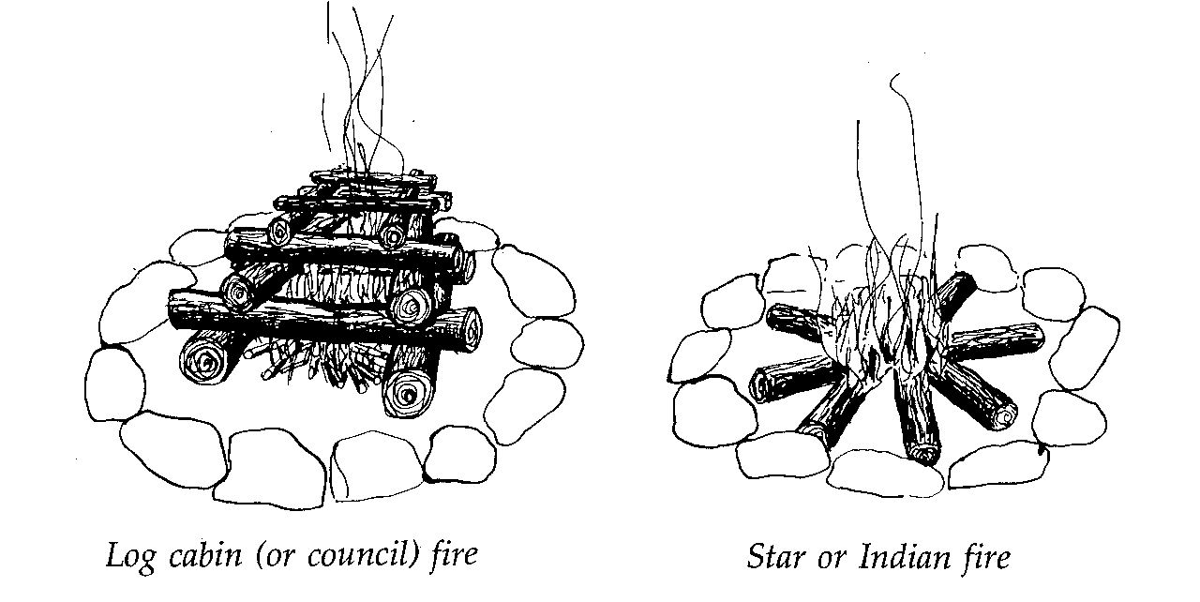

STAR OR INDIAN FIRE—SOMETIMES CALLED THE
“LAZY MAN’S FIRE”
BECAUSE THE WOOD IS
SIMPLY PUSHED INTO
THE FIRE AS IT BURNS.
USE THIS FIRE FOR SLOW
HEAT, AS IN ONE –POT OR
TRIPOD COOKING.

EXTINGUISHING FIRES

REGULAR CAMPFIRES MAY BE EXTINGUISHED BY TWO METHODS.

DIRT METHOD

- LET THE FIRE BURN DOWN.
- SEPARATE THE BURNING PIECES, KEEPING THEM WITHIN THE FIRE AREA.
- POUR DIRT OVER HOT COALS AND ASHES TO SMOTHER THE FIRE.
- MAKE SURE THE FIRE IS COMPLETELY SMOTHERED BEFORE LEAVAING THE AREA.

WATER METHOD

- WET THE AREA AROUND THE FIRE.
- SPRINKLE WATER ON THE FIRE.
- SPREAD OUT THE COALS WITH A STICK.
- SPRINKLE AGAIN WITH WATER.
- POUR WATER ON THE FIRE AND STIR WELL UNTIL ONLY SOAKING WET ASHES REMAIN. DO NOT LEAVE EVEN ONE SPARK THAT COULD LATER BE FANNED INTO A FLAME..
- SPRINKLE ANOTHER BUCKET OF WATER ON THE ASHES.
- COVER THE AREA WITH DIRT, BURYING THE WET ASHES.

COOKING FIRES ARE PUT OUT DIFFERENTLY THAN REGULAR FIRES.

- POUR SALT, SODA, FLOUR, OR SAND ON FLAMING GREASE. DO NOT USE WATER.
- IF POSSIBLE, COVER THE FIRE WITH A METAL LID.
- IF AVAILIBLE, USE A SMALL AEROSOL FIRE EXTINGUISHER.

