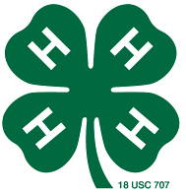
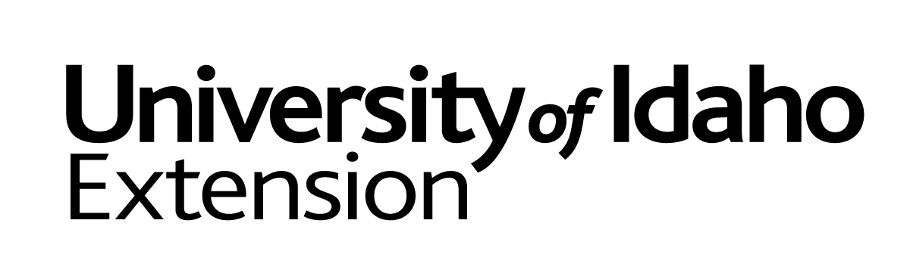
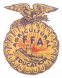
Twin Falls County
YOUTH LIVESTOCK PROGRAM
COMMITMENT TO EXCELLENCE
~PETS~

- I believe that participation in the Twin Falls County Youth Livestock Program should demonstrate my own knowledge, ability, and skill as a feeder and exhibitor of livestock.

- I will do my own work to the full extent I am capable and otherwise will only accept advice and support from others.

- I will not use abusive, fraudulent, illegal, deceptive or questionable practices in the feeding, fitting and showing of my animal(s), nor will I allow my parents, my supervisor, or any other individual to employ such practices with my animal(s).

- I will read, understand, and follow the rules without exception, of all livestock shows in which I am a participant and ask that my parents and the supervisor of my project do the same.

- I wish for my livestock project to be an example of how to accept what life has to offer, both good and bad, and how to live with the outcome.

- I realize that I am responsible for:
The proper care and safe humane treatment of my animals, The production of high quality, safe and wholesome food, demonstrating strong moral character as an example to others.

- I consent to having my animal(s) subjected to drug testing.

_____________________________ _______________
Exhibitor Date:

_____________________________ ________________
Parent or Guardian Date:

_____________________________ ________________
Project Supervisor Date:

_____________
Office Use Only

Completed and signatures certify that the exhibitor is eligible to participate fully in the Twin Falls County Youth Livestock Program.

Non breeding or non market Animal Projects MUST turn this signed and dated sheet in at time of project deadline

The University of Idaho provides equal opportunity in education and employment on the basis of race, color, religion, national origin, gender, age, disability, or status as a Vietnam-era veteran, as required by state and federal laws.

