TWIN FALLS COUNTY
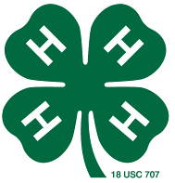
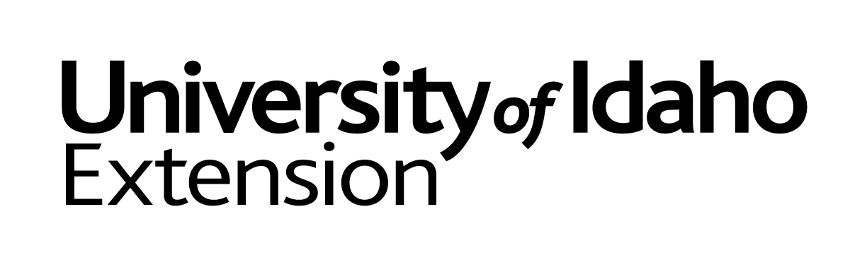
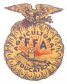
YOUTH LIVESTOCK PROGRAM
COMMITMENT TO EXCELLENCE
BREEDING PROJECTS

- I believe that participation in the Twin Falls County Youth Livestock Program should demonstrate my own knowledge, ability, and skill as a feeder and exhibitor of livestock.

- I will do my own work to the full extent I am capable and otherwise will only accept advice and support from others.

- I will not use abusive, fraudulent, illegal, deceptive or questionable practices in the feeding, fitting and showing of my animal(s), nor will I allow my parents, my supervisor, or any other individual to employ such practices with my animal(s).

- I will read, understand, and follow the rules without exception, of all livestock shows in which I am a participant and ask that my parents and the supervisor of my project do the same.

- I wish for my livestock project to be an example of how to accept what life has to offer, both good and bad, and how to live with the outcome.

- I realize that I am responsible for:
The proper care and safe humane treatment of my animals, demonstrating strong moral character as an example to others.

- I consent to having my animal(s) subjected to drug testing.

------------------------------------------- -----------------------
Exhibitor Date:

------------------------------------------- -----------------------
Parent or Guardian Date:

------------------------------------------- -----------------------
Project Supervisor Date:

________________
Office Use Only

Completed and signatures certify that the exhibitor is eligible to participate fully in the Twin Falls County Youth Livestock Program.

ALL NON-MARKET animals MUST sign and return to the
Twin Falls County Extension Office by June 15.

