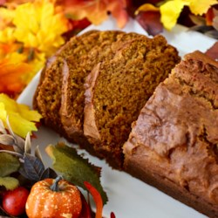 Down East Maine Pumpkin Bread

* Prep 15 m Cook 50 m Ready In 1 h 5 m

*Recipe By :*Laurie Bennett

Ingredients

* 1 (15 ounce) can pumpkin puree
* 4 eggs
* 1 cup vegetable oil
* 2/3 cup water
* 3 cups white sugar
* 3 1/2 cups all-purpose flour
* 2 teaspoons baking soda
* 1 1/2 teaspoons salt
* 1 teaspoon ground cinnamon
* 1 teaspoon ground nutmeg
* 1/2 teaspoon ground cloves
* 1/4 teaspoon ground ginger

Directions

1. Preheat oven to 350 degrees F (175 degrees C). Grease and flour three 7x3 inch loaf pans.
2. In a large bowl, mix together pumpkin puree, eggs, oil, water and sugar until well blended. In a separate bowl, whisk together the flour, baking soda, salt, cinnamon, nutmeg, cloves and ginger. Stir the dry ingredients into the pumpkin mixture until just blended. Pour into the prepared pans.
3. Bake for about 50 minutes in the preheated oven. Loaves are done when toothpick inserted in center comes out clean.