**Two Liter Bottle Survival Kit**

**By Roxanne Berheim**

**Items Needed:**

-Two Liter Bottle (washed out and dry)

-Recipe Card (2)

- Pencil

- Mini sticky note pad

-Duck Tape (2 feet)

-Medical Tape (2 feet)

-Scotch Tape (2 feet)

-Sewing Needles (2 or 3)

-Paper Clips (6)

-Safety Pins (6)

-Fishing Line (10 feet)

-Fishing Hooks (3)

-Garbage Bag (1-33 gal)

-Hand Sanitizer

-Alcohol Wipes (3)

-Bandana (1)

-Gauze Pads (3)

-Burn Ointment (1)

-Band Aids (6)

-Thread

-Tin Foil (1 Square Sheet)

-Zip lock Bag (1)

-Hard Candy (6)

-Lint or Cotton Balls

-Steel Wool

-Whistle \

-Mini Compass Sometimes this can be found as one item from the dollar store

-Mini Flashlight /

-Twine, String, or Yarn (3 feet)

-Lighter (optional if parents want to provide later)

-Waterproof matches (optional if parents want to provide later)

-Fire Starter (Optional)

-Apple Cider Vinegar Pills (Optional)

-Chlorine Tablets (Optional)

**Instructions:**

1. Cut Bottle in half-leaving the spout as one 1/4 and the bottom as the other ¾

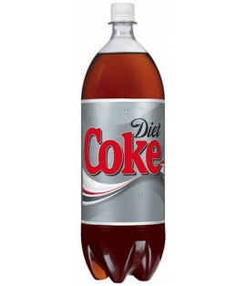

Tape

1. Take pencil and wrap tapes around the pencil in sections
2. Thread wind up and hold together with two paperclips
3. Fishing line wind up and hold together with two paperclips
4. Pierce needles and safety pins through one recipe card
5. Fold up garbage bag
6. Fold up bandana
7. Fold up tin foil
8. Place thread, fishing hooks & line, pins & needles, tin foil, garbage bag, bandana in zip lock bag
9. Take recipe card and list all items that are going to be in the bottle
10. Cover with clear tape or shelf liner to make water proof
11. Place list on the inside of the bottom part of the bottle, so it can be seen from the outside
12. Place all items in the bottom of the bottle
13. Tie twine, string or yarn to the spout (take both ends and tie them in a square knot around spout)
14. Now take spout and fit it onto the bottom of the bottle
15. Seal with a piece of Duck Tape around the bottle.